GIT HOL 5
Cleanup & Push
- Verify Clean Working Tree
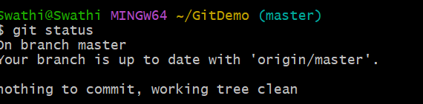
- List All Branches
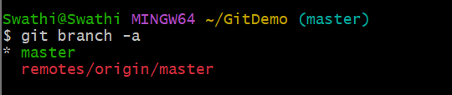
- Pull Latest Changes from Remote
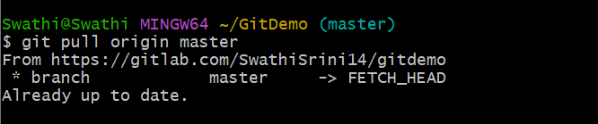
- Final Push Confirmation
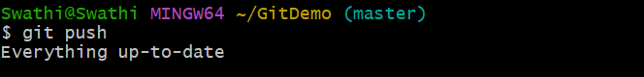
- View Complete Commit History
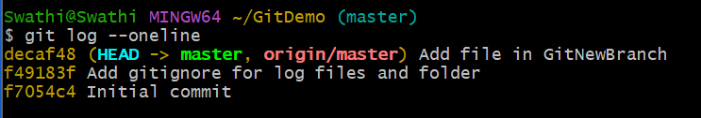
- Verify Final State on GitLab
